**The 2016 CADS Annual Festival: Celebrate CADS 40th Anniversary**

**“Skiing is for Everyone”**

The CADS Festival is a fun filled adaptive skiing / snowboarding week held annually at resorts across Canada. CADS is hosting the 2016 festival at Kimberly, Alpine Resort, Kimberley B.C. Sunday March 20 to Friday March 25. It is a celebration of CADS 40th Anniversary. Student skiers are encouraged to register for adaptive ski/board improvement lessons, camaraderie, fun games, on snow activities, and awards banquet. Families and friends are encouraged to join. Certified CADS Instructors from programs across the country volunteer their time to work with our students for the week. Details are available on the [Festival webpage](http://disabledskiing.ca/events/)

**Location** Kimberly Alpine Resort, 301 North Star Road, Kimberley, British Columbia V1A 2Y5 <http://www.skikimberley.com>

Phone 250-427-4881Fax 250-427-3927

E-mail: [information@skikimberley.com](mailto:information@skikimberley.com)

Virtually ski their runs on google map / google earth

80 runs, renowned for impeccable snow conditions

**Dates** Sunday March 20 to Friday, March 25, 2016

**Accommodation** Trickle Creek Lodge near Owl T-Bar <http://tricklecreeklodge.com/> Polaris Lodge near Northstar Express Quad <http://polarislodge.com> See below for room rates and reservation instructions

**Skiers To Do** In February apply forCADS Bursary and CADS-NCD funding. In advance of the application deadline, express interest in the Festival as early as possible to facilitate planning and fund raising..

Attending the Festival is an experience of a lifetime for anyone who has never been. You will not be disappointed!

Visually limited skiers wanting to go are required to find a guide willing to go and pay their own way.

Pending CADS-NCD funding, early registration for the Festival for your week of fun, learning, and excitement is strongly suggested via the CADS website [www.disabledskiing.ca](http://www.disabledskiing.ca). Reserve your flight and room early for best availability and rates. Consult N

**Clubs To Do** CADS-NCD Programs advertise the CADS Festival in fall newsletters and reminder in e-mails. Start planning and fund raising now, continue through the season.

Program coordinators, guides, coaches please canvas their programs to see who wants to go / who is ready.

Set up a skill development plan so each CADS Festival skier has skills necessary for the Festival. Carry out plan over the season

**CADS-NCD** Feb 15, 2016 NCD would like to know who plans to attend

We can finalize funding, appropriate coaches / volunteers, etc.

**Registration** Festival Registration is available on the [CADS webstore](https://netforum.avectra.com/eweb/Shopping/Shopping.aspx?Logoff=Yes&Site=CADS)

After read in all the information in this package, [click here to register and pay.](https://netforum.avectra.com/eweb/Shopping/Shopping.aspx?Site=CADS&WebCode=Shopping)

**Application Forms** After completing online Registration and paying applicable fee, students, prospective Festival Instructors and volunteers must complete appropriate application form so CADS can ensure best possible Student/ Instructor assignments and festival experience.

* Student Application Form [can be found here.](http://disabledskiing.ca/wp-content/uploads/CADS-2016-Festival-Student-Application.docx)
* Instructor Application Form [can be found here.](http://disabledskiing.ca/wp-content/uploads/CADS-2016-Festival-Instructor-Application.docx)
* Volunteer Application Form [can be found here.](http://disabledskiing.ca/wp-content/uploads/CADS-2016-Festival-Instructor-Application.docx)

**Please e-mail completed application forms to** [**deanna@disabledskiing.ca**](mailto:deanna@disabledskiing.ca?subject=2016%20festival%20instructor%20application%20form) **by February 22, 2016**

**Accommodations** **Trickle Creek Lodge**

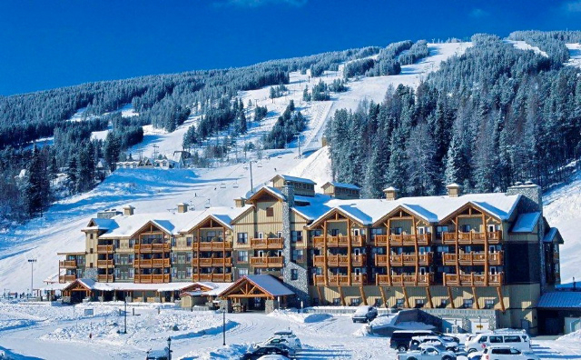

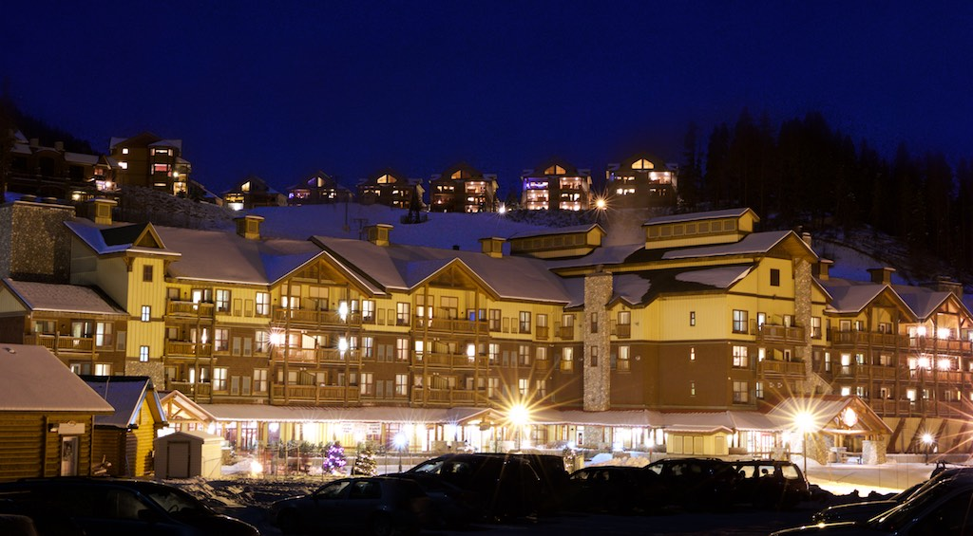

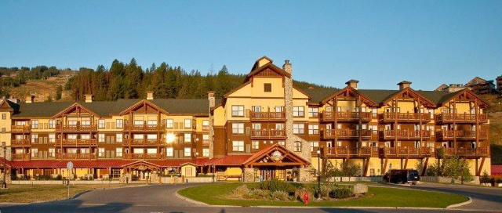

500 Stemwinder Drive, Kimberley, BC V1A 2Y6

Phone 250-427-5175 Toll Free 877-282-1200 Fax 250-427-5129

<http://tricklecreeklodge.com/> Email [infomation@tricklecreeklodge.com](mailto:infomation@tricklecreeklodge.com)

All-suite hotel located in the heart of the Alpine Village near Owl T-bar. Features include outdoor heated swimming pool, 2 outdoor hot tubs, fitness room, BBQ area, ski storage, guest laundry, Montana’s restaurant & lounge. Slopeside Market. Suites include full kitchens, gas fireplaces, free wifi, and balconies

**Polaris Lodge**

[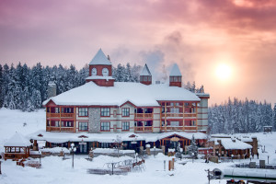](http://polarislodge.com/wp-content/uploads/2013/04/Polaris-Sunrise.jpg)

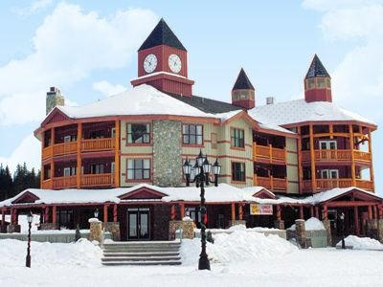

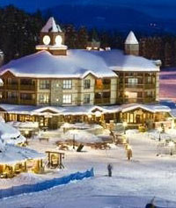

301 Northstar Blvd, PO Box 220 Kimberley, BC, V1A 2Y5

Phone 250.427.5175 Toll Free 877.282.1200 Fax 250-427-5176

<http://polarislodge.com> Email [information@tricklecreeklodge.com](mailto:pandrews@tricklecreeklodge.com)

Located in the center of Kimberley Alpine Resort Village, near Northstar high speed quad lift, Features include ski storage, guest laundry, free wifi, Stemwinder Bar and Grill. Rooms are equipped with kitchens, slate fireplaces, and beautifully appointed bathrooms with Jacuzzi bath tubs. Access to underground parking, fitness center, swimming pool and other amenities are at Trickle Creek.

**Room Rates Booked Based on Availability ONLY**

[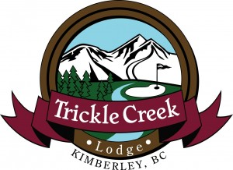](http://disabledskiing.ca/wp-content/uploads/March-20-25-2016-CADS-Accommodtaion-Rates.pdf)

**Trickle Creek Lodge For reservations please call 1-877-282-1200 Ext 2**

**For more info please see their website:** [**www.tricklecreeklodge.com**](http://www.tricklecreeklodge.com)

All rooms are booked based on availability ONLY! 48 Hour Cancellation period applies and a Major Credit Card is required to guarantee all accommodation reservations.

There is a small Market & Deli Counter located in the Hotel, the hotel also has the Montana's Cookhouse & Lounge on-site.

The following discounted room rates have been provided to anyone attending the:

**CADS 2016 Event - March 20-25, 2016**

*These rates are good for 1 days prior to and 1 days after the event dates.*

**Trickle Creek Lodge These rates are Good for March 19-26, 2016 ONLY**

Studio Suites $81 + 15% tax per room per night (max occupancy 2 to 4 people)

One Bedroom Suites $81 + 15% tax per room per night (max occupancy 2 to 4 people)

Two Bedroom Suites $139 + 15% tax per room per night (max occupancy 4 to 6 people)

[Polaris Lodge](http://disabledskiing.ca/wp-content/uploads/March-20-25-2016-CADS-Accommodtaion-Rates.pdf)

**Polaris Lodge These rates are good for March 19-26, 2016 ONLY**

One Bedroom Suites $81 + 15% tax per room per night (max occupancy 2 to 4 people)

One Bedroom Master Suites $89 + 15% tax per room per night (max occupancy 2 to 4 people)

Two Bedroom Suites $145 + 15% tax per room per night (max occupancy 4 to 6 people)

Three Bedroom Suites $199 + 15% tax per room per night (max occupancy 6 to 8 people)

Lock off (Standard Hotel Room) $72 + 15% tax per room per night (max occupancy 2 people)

Please note that if your group wants to have more than the preferred occupancy in a room an extra $20 per head + taxes will be applied to that room rate.

**************************************************************************************************

**\*\*PLEASE NOTE\*\***

Guests calling to reserve a room ***MUST QUOTE*** that they are part of the

***CADS 2016 EVENT***

This will assure them that they will receive the discounted rate provided!

If they do not quote the above name they **WILL NOT** receive the discounted rate.

**Thank you,**

**Group Sales Manager**

**Jill Bellm**

**Travel** Attendees are responsible to book and pay for their own travel.

Kimberley is located approximately 400 km southwest of Calgary

Fly to Calgary, rent a vehicle, drive 4 to 5 hours to Kimberley Alpine Resort, recommend groups of 4 go together to minimize costs.

Fly to Cranbrock (small airport). Trickle Creek Lodge runs a courtesy shuttle from Cranbrook airport to Kimberley Alpine Resort.

To book the shuttle please email [deanna@disabledskiing.ca](mailto:deanna@disabledskiing.ca) with your flight arrivals and we will communicate that with the hotel and arrange for the shuttle. If we exceed their capacity, there is an alternative shuttle available for a small fee.

**Funding Plan and estimate about $1,800 to $2,500 per person** depending on circumstances, taxis, flights, accommodation choices, SKIMP, meals, equipment rental if needed, personal incidentals, etc.

If you plan to attend, please begin fund raising early.

Every person attending should pay at least some of their own costs.

Clubs and Division to confirm support based on availability of funds.

2016 CADS Festival Bursary Info at **http://disabledskiing.ca**

**To Bring** Make sure you bring proper snow attire including:

Skis, poles, boots, and or adaptive devices

Helmet

Gloves

Ski/Riding pants

Ski/Riding jackets

Sweaters & pants

Under garments

Extra socks

Sunscreen

Toque

Goggles

Sunglasses

Neck Gator

Personal Ski Locks

Personal necessities / medications etc

**Equipment Rental** Participants are responsible for supplying their own equipment.

Ski and snowboard rentals are available. Kimberley is offering a 25% discount for regular equipment and 10% discount for high performance gear. Contact [deanna@disabledskiing.ca](mailto:deanna@disabledskiing.ca) to arrange bookings.

**Ski Improvement** CADS Instructors attending Festival working with students

**(SKIMP)** are the best in Canada, all certified at CADS Level 2, 3, or 4 with years of experience.

There are lessons for all levels from beginner all the way up to Black Diamond and Racing in either a group or individual setting.

**Student Opportunities $395 cost** includes 5 mornings of lessons, Festival Banquet, all activities and a welcome package. Students must be current CADS members to participate. Some students will also ski in the afternoons, while others will have opportunity to explore and enjoy the resort amenities with their families. There are three student options:

* + - * **Ski Improvement (SKIMP)**: For anyone needing hands-on assistance or tethering.
      * **Black Diamond:** For independent skier or snowboarder looking for more mileage wanting to explore more variable terrain.
      * **Race:** For race-oriented skier or snowboarder (race experience not required). Must be completely independent and able to ski blue and black level terrain.

Student Application Form [can be found here.](http://disabledskiing.ca/wp-content/uploads/CADS-2016-Festival-Student-Application.docx)

**NOTE:** We do not provide adaptive equipment. Equipment (i.e. sit skis) can be shipped ahead to Kimberley if required, with advance notice. If you will have a problem providing your own adaptive equipment, please contact [deanna@disabledskiing.ca](mailto:deanna@disabledskiing.ca) to discuss.

**Teaching Opportunities Instructors $60 cost** includes 6 days of lift passes, Festival Banquet, all activities and a welcome package. Any CADS Instructor or Volunteer is encouraged to attend Festival and enjoy the week; they must be a current CADS member. To qualify as a Lead Instructor, the candidate must have a minimum of Level 2A or New FULL Level 2 CADS Certification and be available for the entire week; if approved, the candidate is also eligible for an honorarium. Some Level 1 and 2 Instructors may qualify, depending on the circumstances.

Instructor Application Form [can be found here.](http://disabledskiing.ca/wp-content/uploads/CADS-2016-Festival-Instructor-Application.docx)

**Volunteer Opportunities** A person wishing to volunteer or an Instructor who is not qualified to teach as a Lead instructor may apply to volunteer as an assistant. If we need you, we will provide lift tickets; you must be available for the entire week.

**MANDATORY Instructor/ Volunteer Orientation** will take place on the hill on Sunday 1-4pm.

SKIMP (Ski Improvement) for both skiers and boarders will be offered on Tuesday and Thursday afternoons to Festival Instructors and Volunteers, and interested family members of our students.

Please complete the Instructor application, which [can be found here](http://disabledskiing.ca/wp-content/uploads/CADS-2016-Festival-Instructor-Application.docx).

**Training and Certification Opportunities:** Certification Courses for Instructors: You must sign up in advance at the [CADS online store.](https://netforum.avectra.com/eweb/Shopping/Shopping.aspx?Site=CADS&WebCode=Shopping)

* + - * The **ASD/CI Module (Level 1 and 2)** free update will be offered on Monday afternoon
      * The **Sit Ski Module (Level 1 and 2)** free update will be offered on Wednesday afternoon.
      * **A level 3 course** will be offered
      * **A Level 4 course** will be offered

**NOTE:** The two Modules are free for any Instructor certified under the former certification system who would like to upgrade to the NEW system.

**Friends and Family** **make it possible for our students to attend! We would love to have you join us. $60 cost** includes 25% discounted lift passes (must show proof of CADS membership), Festival Banquet, all activities and a welcome package. There are lots of amenities at the resort for non-skiers to enjoy. They must be a CADS member to participate.

**Itinerary** There are many activities during the week on and off hill The CADS national Board and the Technical Committee meet. On Sunday events include registration, instructor orientation and Opening Ceremonies where students meet their instructors. Student lessons run each morning with your CADS certified instructors. The Annual General Meeting is on Monday evening. A “Guesstimation” race is on Thursday. The Awards Dinner Festival Banquet on Thursday evening includes a silent auction and slide show of the week’s events. Daily Apres Ski Socials to meet other participants and discuss the days skiing. Daily activities, mind teasers and challenges, including snow bocce and the Guesstimation Race

**2016 CADS Festival Schedule**

**Kimberley Alpine Resort, BC**

|  |  |  |  |
| --- | --- | --- | --- |
| **Date** | **Time** | **Event & Location** | **Whom** |
| Friday, March 18 | Board & TC arrivals | | |
| Saturday,  March 19 | 9am-5pm | CADS national board meeting  Purcell Room, Trickle Creek Lodge | National Board of Directors |
| Technical Committee meeting  Purcell Room, Trickle Creek Lodge | TC only |

*Note: the National ‘Office’ will be set up in the Purcell Room for the duration of the Festival.*

|  |  |  |  |  |
| --- | --- | --- | --- | --- |
| **Sunday,**  **March 20** | 9am-3pm | Registration Desk Open  Main Foyer, Trickle Creek Lodge | | ALL |
| 9am-noon | Board and Division Rep Meeting | Purcell Room | TC only |
| Technical Committee Meeting | Purcell Room | National Board and Division Reps |
| 1-4pm | Instructor/ Volunteer Orientation  Meet outside Purcell Room ready to ski. | | Mandatory |
| 7-8pm | Opening Ceremonies and introductions of student/ instructor pairings  Purcell Room, Trickle Creek Lodge | | ALL |

|  |  |  |  |  |
| --- | --- | --- | --- | --- |
| **Monday,**  **March 21** | 8:30am-10am | Registration Desk Open | Main Foyer  Trickle Creek Lodge | ALL |
| 9:30am-noon | On-Snow Sessions  Meet up with your Instructor at the Purcell Room, Trickle Creek Lodge | | ALL |
| Noon-1pm | LUNCH | | |
| 1-4pm | Certification for Instructors (optional)  Meet up at the Purcell Room and on hill. | | Instructors |
| 4-6pm | Après Ski Social  Polaris Lodge Room 210 | | ALL |
| 7pm | Annual General Meeting  Purcell Room | | ALL |

|  |  |  |  |
| --- | --- | --- | --- |
| **Tuesday,**  **March 22** | 9:30am-noon | On-Snow Sessions  Meet up with your Instructor at the Purcell Room, Trickle Creek Lodge | Students and Instructors |
| Noon-1pm | LUNCH | |
| 1:30-3pm | SKIMP for Instructors and Volunteers (ski/ board)  On-hill. Meet on the snow outside Purcell Room entrance, ready to ski. | ALL |
| 1-3pm | New CADS National Board Meeting  Purcell Room | New National Board of directors |
| 4pm | Snow Bocce | ALL |
| 4-6pm | Après Ski Social  Polaris Lodge Room 210 | ALL |
| tba | Locally hosted event,  tbd | ALL |

|  |  |  |  |
| --- | --- | --- | --- |
| **Wednesday,**  **March 23** | 9:30am-noon | On-Snow Sessions  Meet up with your Instructor at the Purcell Room, Trickle Creek Lodge | Students and instructors |
| Noon-1pm | LUNCH | |
| 1-4pm | Certification for Instructors- Sit Ski Module | Jamie Mc (tbc) |
| 4-6pm | Après Ski Social  Polaris Lodge Room 210 | ALL |
| tba | Locally hosted event  Tbd | ALL |

|  |  |  |  |  |
| --- | --- | --- | --- | --- |
| **Thursday,**  **March 24** | 9:30am-noon | On-Snow Sessions  Meet up with your Instructor at the Purcell Room, Trickle Creek Lodge | | All |
| 10 am-noon | Guesstimation Race  The Meadows | | ALL |
| Noon-1pm | LUNCH BREAK |  |  |
| 1:30-3pm | SKIMP for Instructors and Volunteers- both ski and snowboard | | Jamie S, Jim, Tommy, Brian Rode, Christian/ Tom G (snowboard)-tbc |
| 6pm | Reception, Dinner and Awards Banquet  Kimberley Conference Centre (on site) | | ALL |

|  |  |  |  |
| --- | --- | --- | --- |
| **Friday,**  **March 21** | 9:30am-noon | On-Snow Sessions  Meet up with your Instructor at the Purcell Room, Trickle Creek Lodge | Students and instructors |
| Noon-1pm | Lunch, SKIMP Awards and Wrap-Up  Outdoors | ALL, led by Jamie Spencer |
| Departures | | |

|  |  |
| --- | --- |
| **Saturday, March 22** | Departures for many Eastern Canada delegates |

**Link to Article on Para Training at Kimberley Alpine Resort**

[**http://skikimberley.com/news-and-info/paralympic-training-centre/**](http://skikimberley.com/news-and-info/paralympic-training-centre/)

**The Mountain Discover the Four Faces of Kimberley**

Kimberley is located southeast B.C. in the heart of the East Kootenays in the [Purcell Mountains](http://en.wikipedia.org/wiki/Purcell_Mountains), on the east face of *North Star Hill*. <http://skikimberley.com/the-mountain/>

Known for light fluffy snow, short lift lines, beautiful views and an abundance of sunny days. Laid back and friendly atmosphere.

Offers everything from wide-open groomed runs on the frontside with powder stashes that last for weeks to adventurous steeps and North America's largest gladed terrain, The Black Forest, on the backside.

Assortment of on-mountain and ski-in/ski-out accommodation, including [Trickle Creek](http://www.tricklecreeklodge.com/) Lodge located directly at the main lift base and a unique Bavarian-themed downtown.

**Simple Map of Kimberley Alpine Resort**

<http://www.skikimberley.com/images/vacations/accomm_map_LRG.gif>

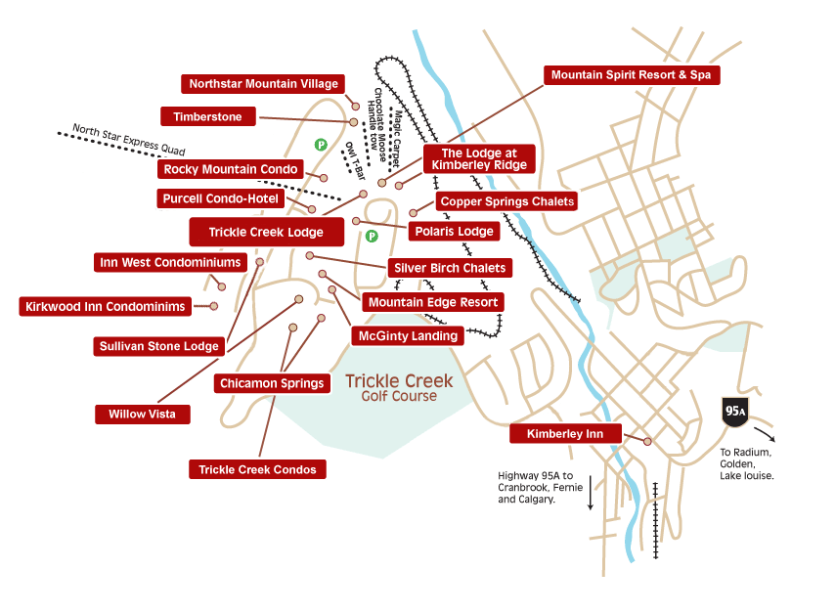

|  |  |  |  |  |  |  |  |  |  |  |  |  |  |  |  |  |  |  |  |  |  |  |  |  |  |  |  |  |  |  |  |  |  |  |  |  |  |  |  |  |
| --- | --- | --- | --- | --- | --- | --- | --- | --- | --- | --- | --- | --- | --- | --- | --- | --- | --- | --- | --- | --- | --- | --- | --- | --- | --- | --- | --- | --- | --- | --- | --- | --- | --- | --- | --- | --- | --- | --- | --- | --- |
| |  |  |  |  |  | | --- | --- | --- | --- | --- | | **Lift Statistics** | | | | | | **Lifts** | **Length** | **Vertical** | **Capacity** | **Ride Time** | | Owlette Magic carpet | 180ft /55m | 30ft/9.1m | 600/hr | 4 minutes | | Owl T-bar | 886ft /270m | 176ft/54m | 1,200/hr | 2.5 minutes | | Tamarack double chair | 3,600ft /1097m | 1,181ft/360m | 1,052/hr | 8.5 minutes | | Easter triple chair | 3,365ft /1062m | 1,164ft/355m | 1,200/hr | 7 minutes | | North Star Express HS quad | 7,787ft /2373m | 2,100ft/640m | 2,400/hr | 7 minutes | |  |  | Total Capacity**: 6,452/hr** | | | |
| |  |  |  | | --- | --- | --- | | http://2r8adu30letk19hpne1r6b6h.wpengine.netdna-cdn.com/img/Trail_Map_1314.jpg   |  |  | | --- | --- | | |  | | --- | |  | | | | [Kimberley Trail Map[.jpg] 897K](http://2r8adu30letk19hpne1r6b6h.wpengine.netdna-cdn.com/img/Trail_Map_1314.jpg)  For a higher res version, go to the [RCR Media Centre](http://skircr.com/imagelibrary/kimberley.asp)   |  |  | | --- | --- | | [http://www.skikimberley.com/images/icons/pdficon2.gif](http://www.skircr.com/imagelibrary/trailmaps/Kimberley_Trail_Map_0910web.pdf) | . | |   **Top Elevation: 6,500 ft / 1,982 m  Base Elevation: 4,035 ft / 1,230 m  Vertical Rise: 2,465 ft / 751 m  Skiable Acres: 1,800 acres / 729 hect  Longest Run: Ridgeway 3.97 mi/6.4 km**  **Number of Lifts: 5**  1 High Speed Quad (North Star Express),  1 Triple Chair (Easter),  1 Double Chair (Tamarack),  1 T-Bar (Owl),  1 Magic Carpet  **Number of Runs: 80 68 total runs plus another 12 in the Glades** Beginner: 20%  Intermediate: 42%  Advanced: 38%  **Ski Season Early December - Mid April**  Average Snowfall: 150" - 400cm  Average Temperature: -5°C / 23°F |
|  |

**Warm Up Runs Warming up** is an important component to a healthy injury-free day. Take the North Star Express lift to the top and get off to skiers right. Then take the run 'Bradford's BLVD' to the bottom. This is a soft transitional corduroy run - perfect for getting those legs loose!

Other Recommended Warm up Runs:

Main, Buckhorn, Stemwinder, Twiligh

**Must Do Runs**

All Over (40), Notre Dame (63), Stemwinder (16), Nate's Way (24)

Bradford's BLVD (13), Caper (39), Dean's Left and Right! (48,46)

Tamarack (28)

**Beginner**

Back Track, Caper, Lower Caper, Upper Caper, Easy Way

Hoot's Way, Main, Midnight, Northstar Trail, Owl Area

Pine Flats, Ridgeway, Vimy Ridge, Nate's Way

**Intermediate**

All Over, Anton’s Top, Buckhorn, Dean Left, Dean Right, Dinkum

Dreadnaught, Ego Alley, Mambo, Main, Midget, Midwinder

Notre Dame, Purl, Rosa, Stemwinder, Twilight, Utopia

1/2 Dreadnaught, 1/2 Rosa, 1/2 Twilight

**Advanced**

Magma, Tamarack, Upshot, Kimberley Rail Park

**Ask the Experts** **Let Them Show You the Mountain.**

If you're looking for secret snow stashes, lift shortcuts, abundance of resort history and/or you just need someone to lean on for a few hours, hook-up with one of our Mountain Hosts! They know everything and are also really cool! Our Mountain Hosts offer tours everyday for intermediate (green circle/blue square) to advance (black diamond) skiers and riders. They'll show you how to make the most of your day on the hill.

**Must Eats** **Montana's Cookhouse** open all three meals year-round located in Trickle Creek Lodge, menu signature items include fall-off-the-bone Smokehouse Ribs, Canadian AAA Steaks. appetizers, salads, salmon, hamburgers, sandwiches, pasta, decadent desserts. Bar and lounge extensive cocktail menu, sports on TV.

**The Stemwinder Bar & Grill** Kimberley après spot. Full service bar, heated outdoor seating, expanded sundeck patio for the BBQ cookouts, located at the base of the resort. This is the spot for Après ski music and entertainment. Waffle Poutine Fries, Buckhorn Burger, sheperd’s pie & soup, Irish creams, coffees and whiskey.

**Slopeside Market & Deli** – Get your coffee fix. Proudly brewing Starbucks Coffee. Morning coffee and muffins specials, fresh deli sandwiches, soups and salads, monster dogs, cookies. Slopeside will get you fueled up and on the slopes in no time. Located in the Polaris Lodge, next to the Resort Rental Shop

**Kootenay Haus** - Mountaintop warming hut offers a small area for enjoying your bagged lunch and washroom facilities. Access is available from the top of the North Star Express Quad.

**Other**  Two restaurants, marketplace deli and a slopeside cafeteria on-site!

Day Lockers available for a charge!

Fire pit at outdoor Ice skating rink

Sports Alpine Retail Shop!

Warming Hut (Kootenay Haus) above North Star Express Lift!

Winter Sports School

World Class Grooming Technicians

Downtown Shuttle Service

Nordic Trails

Children’s Services with certified professional staff

**Kimberley Trail Map** [**http://2r8adu30letk19hpne1r6b6h.wpengine.netdna-cdn.com/img/Trail_Map_1314.jpg**](http://2r8adu30letk19hpne1r6b6h.wpengine.netdna-cdn.com/img/Trail_Map_1314.jpg)

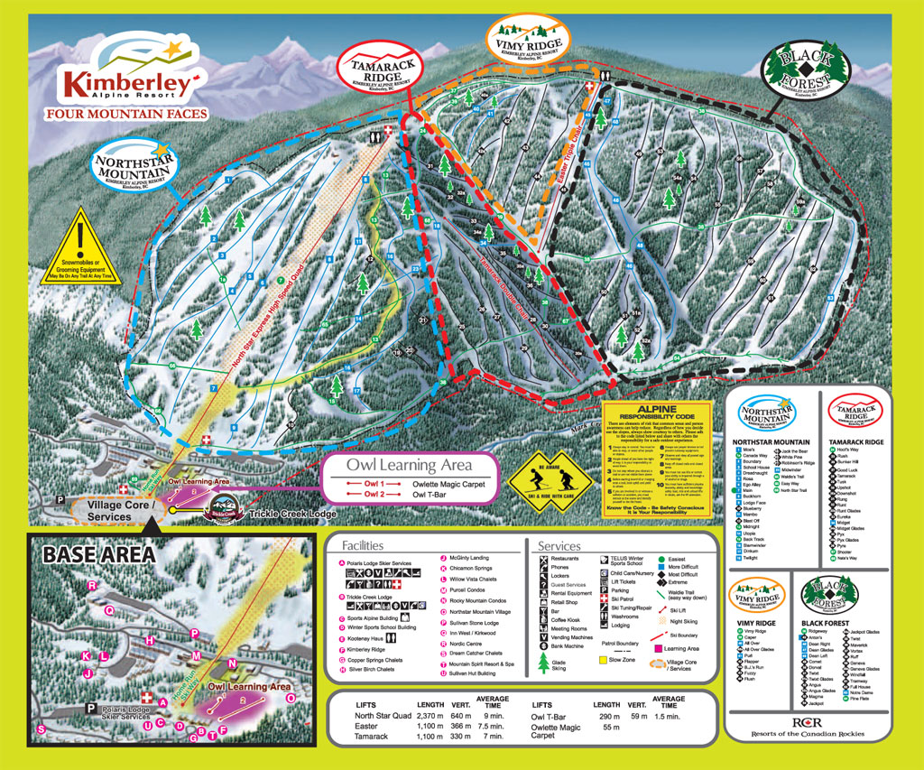

Kimberley Web Cam Top of North Star Express Quad.

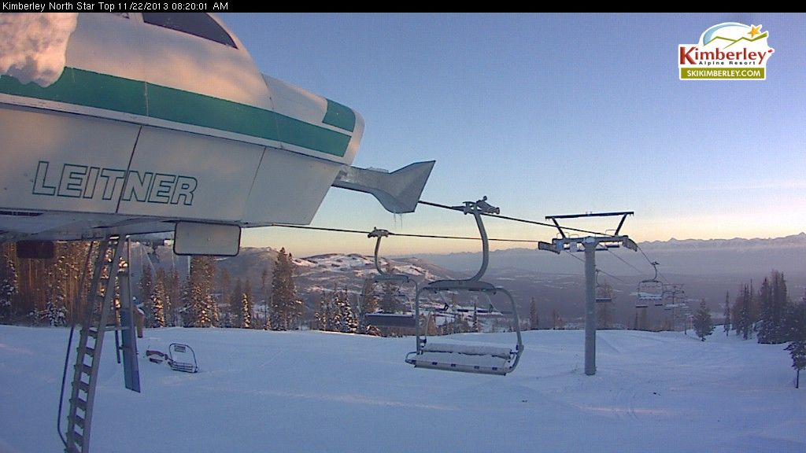

**2015 CADS Festival Group Picture**

