**President’s Report**

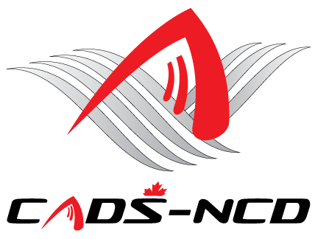

**Annual General Meeting**

**November 28, 2024**

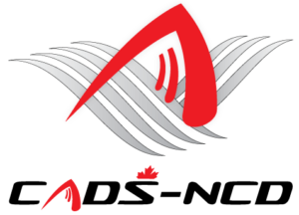

[Edelweiss](http://www.skiedelweiss.com/)

[](http://www.calabogie.com/)

[](http://campfortune.com/fr/bienvenue/)

[](http://www.mountpakenham.com/)

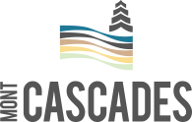

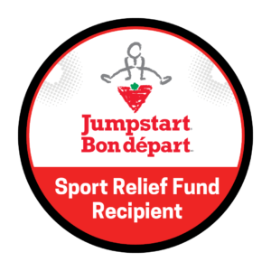

# CADS – NCD President’s Report

I am so pleased to submit my President’s Report for the CADS – NCD 2023-2024 fiscal year from July 1, 2023 to June 30, 2024.

CADS – NCD had a successful 2023-2024 adaptive ski and snowboard season. All programs were on the hill in a safe manner. We continued promoting safe fun learning in inclusive snowsports environments focusing on ability and diversity of all members.

Our enrollment continues to grow towards pre-pandemic seasons. We had a solid safe healthy showing. Total enrolment was 492 members. The season success was made possible by 272 dedicated volunteers or instructors who through our programs delivered adaptive snowsports opportunities to 220 student skiers and snowboarders who have various physical, cognitive, and other challenges.

I continue to appreciate and acknowledge all the support provided by the resorts hosting our programs; Camp Fortune, Mont Cascades, Sommet Edelweiss, Mount Pakenham and Calabogie Peaks.

CADS – NCD continued to receive donations from our supporters. I sincerely thank all new and recurring sponsors who donated financially to CADS - NCD and our programs. Put simply, we could not be in a position to do what we do without your generosity. Fundraising provided a solid financial backbone for our programs and services. Your efforts and generosity will continue to help us operate all our programs, train instructors, support travel to events, and purchase expensive adaptive equipment necessary to make it all happen.

Thank you to our external partners, volunteers, program leadership groups, and the CADS - NCD Board of Directors for your continuing support, dedication, passion and for the time you give to enrich lives of our participants. I appreciate the strategic advice provided by the CADS – NCD Board of Directors and CADS National. You all enabled CADS – NCD to conduct our affairs on and off the hills in effective and efficient manner. This makes CADS – NCD a most successful and dynamic Division within CADS. We are the best.

Our public accountant BDO Canada once again confirmed that CADS - NCD financial affairs are in good standing order. Despite the unpredictability of the post-pandemic era, CADS – NCD has managed its resources very carefully.

As we look towards next year CADS – NCD’s 46th year of operation, the division and our programs continue to develop management plans for safe operation.

The Board and programs remain committed to ensure continued excellence, good governance, and solid leadership providing further opportunities for as many of our existing members and new participants as practically possible to enjoy SAFE fun learning in adaptive snowsports as a means to integrate fulsomely in society.

We look forward to all our programs and members making 2024-2025 a very successful year in support of the CADS – NCD vision, mission, programs, services, and activities. While the 2024-2025 season will continue to be challenging, I look forward to even more successes in the coming winter.

Respectfully submitted,

**James Dicks**

**President,**

**CADS – NCD**

**819 994-6510**

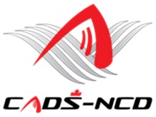

**Website:** [**www.cads-ncd.ca**](http://www.cads-ncd.ca)

**A Division of Canadian Adaptive Snowsports (CADS)**