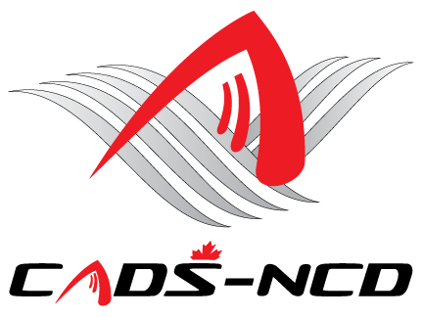

**CANADIAN ADAPTIVE SNOWSPORTS -**

**NATIONAL CAPITAL DIVISION**

**ANNUAL GENERAL MEETING**

**October 29, 2018**

**Application form for:**

**Program Representatives to be a CADS - NCD Director**

**and sit on the CADS - NCD Board of Directors**

**CADS - NCD Program:** : _________________________________

**NAME:**

**ADDRESS:**

**PHONE:**

**E-MAIL**:

Nomination Support Member #1: _________________________________

*Signature*

Nomination Support Member #2: _________________________________

*Signature*

Nomination accepted by nominee: _________________________________

*Signature*

***Notes:***

1. ***Nomination Support Members must be CADS/CADS-NCD members in good standing***
2. ***Signatures can be written in ink, e-signed, or the name typed to sign the form. If the signature is typed, the form should be saved and the file attached to an e-mail and forwarded to the next person. The two (2) nominators and the nominee must “sign” before the form is sent to the CADS - NCD Nomination Committee***
3. ***Nomination application must be sent to the CADS - NCD Nomination Committee Chair David Farough at*** [***DFarough@gmail.com***](mailto:DFarough@gmail.com) ***and please cc Bruce Meredith at*** [***brucemeredith@rogers.com***](mailto:brucemeredith@rogers.com) ***by no later than Monday Oct 22, 2018 as there will be no nominations from the floor.***