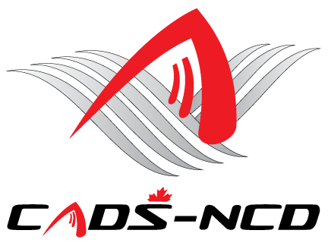

**Canadian Adaptive Snowsports -**

**National Capital Division**

**Annual General Meeting**

**Wednesday October 16, 2019 – 7:00 PM**

**St. Anthony’s Italia Soccer Club**

**523 St. Anthony Street**

**Ottawa, Ontario**

**CADS - NCD 2019 AGM NOTICE**

**CADS - NCD Board of Directors has called an Annual General Meeting (AGM) to be held at 7:00 PM on Wednesday October 16, 2019. The location is St. Anthony’s Italia Soccer Club, 523 St. Anthony Street, (Off Preston at the Queensway) Ottawa, Ontario. Phone 613-233-1083.**

**Light refreshments will be served at 6:15 PM. We anticipate a 7:00 PM start.**

**During this AGM an election will be held for two (maybe three) Directors.**

**All current CADS - NCD members in good standing are eligible to run for these positions. Dedicated members with experience in Administration, Finance, Translation, Information Technology, and or Fundraising are encouraged to apply.**

**Please fill out the attached Application Form and forward it to our Nominations Committee Chair Mr. Paul Johannsen at** [**pkjohannsen@sympatico.ca**](mailto:pkjohannsen@sympatico.ca) **and cc Nomination Committee member Mr. Bruce Meredith at** [**brucemeredith@rogers.com**](mailto:David.Farough@psc-cfp.gc.ca) **no later than October 9, 2019 as there will be no calls for nominations from the floor. Please note that two (2) current CADS-NCD members in good standing are required to support each nomination.**

**Sincerely yours,**

**James Dicks**

**President,**

**CADS - NCD**



**Website:** [**www.cads-ncd.ca**](http://www.cads-ncd.ca)

**A Division of Canadian Adaptive Snowsports (CADS)**