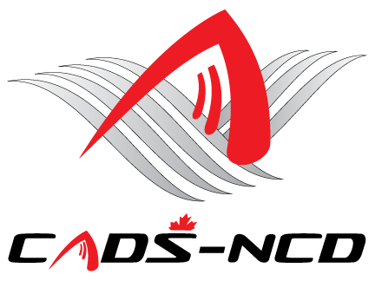

**Canadian Adaptive Snowsports -**

**National Capital Division**

**Virtual Annual General Meeting**

**Thursday December 3, 2020 – 7:00 PM**

**Ottawa Ontario**

Dear Members:

You are cordially invited to attend the CADS - NCD Virtual Annual General Meeting.

This Virtual AGM will be held Thursday December 3, 2020 at 7:00 PM as a zoom call. Call coordinates are below.

**Click here to join Zoom meeting via video:**

<https://us02web.zoom.us/j/88262781046?pwd=eGEzZUs5a3B5UllRSHF5STJUbU1NZz09>

Meeting ID: 882 6278 1046

Passcode: 428557

**Audio only call:**

**+**1 647 374 4685 Canada - Toronto

+1 647 558 0588 Canada - Toronto

+1 438 809 7799 Canada - Montreal

Meeting ID: 882 6278 1046

Passcode: 428557

In order to have quorum so the virtual AGM is official, bylaws require that at least 20 **registered** CADS - NCD members 18+ years of age participate. In addition to all Board members attending, we would need 2 or 3 voting adult members in attendance from each program. That may be many members for smaller programs so hopefully larger programs can bring several participants. All programs are strongly encouraged to get their members to attend.

Hope to see you there.

Sincerely yours,

**James Dicks**

**President,**

**CADS - NCD**

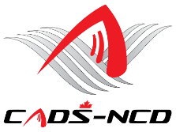

**Website:** [**www.cads-ncd.ca**](http://www.cads-ncd.ca)

**A member of Canadian Adaptive Snowsports (CADS)**