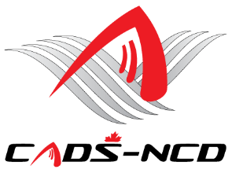

**Canadian Adaptive Snowsports**

**National Capital Division**

**Virtual Annual General Meeting**

**Wednesday November 30, 2022 – 7:00 PM**

**Ottawa Ontario**

**Application form for both:**

**Program Representatives to be a CADS - NCD Director, and**

**Member at Large Positions Elected to the CADS - NCD Board of Directors**

**Represent a CADS-NCD Program:** _______________ (Do Not complete page 2)

**Or**

**CADS–NCD Board Member at Large:** _______________ (Please complete Page 2)

**NAME:**

**ADDRESS:**

**PHONE:**

**E-MAIL**:

Nomination Support Member #1: _________________________________

*Signature*

Nomination Support Member #2: _________________________________

*Signature*

Nomination accepted by nominee: _________________________________

*Signature*

***Notes:***

1. ***Nomination Support Members must be CADS-NCD members in good standing***
2. ***Signatures can be written in ink, e-signed, or the name typed to sign the form. If the signature is typed, the form should be saved and the file attached to an e-mail and forwarded to the next person. The two (2) nominators and the nominee must “sign” before the form is sent to the CADS - NCD Nomination Committee***
3. ***Nomination application must be sent to the CADS - NCD Nomination Committee Chair Mr. Bernie Simpson at*** [***berniesimpson@outlook.com***](mailto:berniesimpson@outlook.com) ***and cc Nomination Committee member Mr. Jim Delaney at*** [***delaney.jim@gmail.com***](mailto:delaney.jim@gmail.com) ***by no later than Wednesday Nov 23, 2022 as there will be no nominations from the floor.***

**Page 2 to be Completed by those nominated for Member at Large Positions only**

**CADS EXPERIENCE:**

**WHAT DO YOU HOPE TO ACCOMPLISH AS A MEMBER OF THE BOARD:**

**\*\*PLEASE KEEP YOUR REPLY TO ONE PAGE MAXIMUM LENGTH\*\*\***