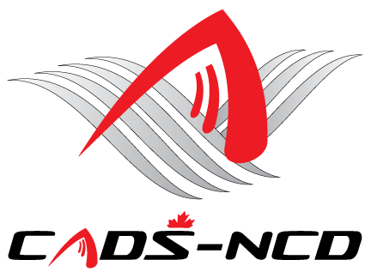
Canadian Adaptive Snowsports - National Capital Division
Virtual Annual General Meeting
Thursday November 28, 2024 – 7:00 PM
Virtual Meeting video and audio conference

(Please see 2nd page to join via Video or via Audio only call in)

AGENDA

- Call to order and credentials report
- Approval of Minutes from previous AGM on November 29, 2023
- Business arising from Minutes
- Present and approve 2023-2024 Financial Statements and our
Public Accountant’s Financial Review of our Fiscal Year 2023-24
- Appointment of Public Accountant for Fiscal Year 2024-2025
- Approval of all 2023-2024 Actions by Board of Directors
- Present and approve 2024-2025 Budget(s)
- President’s Message
- Program updates
- Report by Chair of Nominating Committee regarding the
Election of the Board of Directors
- Vote for Board of Directors.
- Introduce/Announce new Board Members / Directors of the
Corporation
- New Business
- Adjournment

Please see 2nd page to join via video or an Audio only call

You are invited to a scheduled Zoom meeting.
Topic: CADS-NCD Annual General Meeting for 2023-2024
Date &Time: Thursday November 28th, 2024 at 7:00 PM EST
Join Zoom Meeting:

https://us02web.zoom.us/j/4606766076?pwd=eUd6cXlDTjNjV1JnYXpuSXdQUXNtQT09&omn=88065426318
Meeting ID: 460 676 6076
Passcode: 1216
---
One tap mobile
+16475580588,,4606766076#,,,,*1216# Canada
+17789072071,,4606766076#,,,,*1216# Canada
---
Dial by your location:
+1 647 374 4685 - Toronto
+1 647 558 0588 - Toronto
+1 438 809 7799 - Montreal
Meeting ID: 460 676 6076
Passcode: 1216
Find your local number: https://us02web.zoom.us/u/kOiqT6j4z

