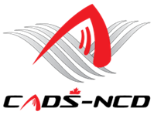
“SKIING IS FOR EVERYONE”

CADS-NCD
 | Technical Committee Operating Budget
 | July 1st 2022 through June 30th, 2023
EXPENSES
5106 · Supplies /  Communication |  |  | $300 | zoom
5138 - Lift tickets |  |  | 3,000 | Lift passes, including certification events and pre-certification training
5146 · Training Travel |  |  | 2,000 | Jamie to perform L3
5310 · Training
 |  | 5312 · CADS National Certification | 1,000
 |  | 5314 · CADS Pre Course | 2,000
TOTAL |  |  | $8,300
INCOME
 |  | Direct funding from NCD | $2,000
 |  | Prorated from programs at Yr. end | 6,300
TOTAL |  |  | $8,300

Notes:
For that we plan to provide
2 x Level 1 courses (at different locations), each with pre-certification training
- 1 x Level 1 course with pre-certification training
- 1 x Level 3 course

